**Unit Test Document**

The Data Structure being tested was the doubly linked list

The three tests performed were on the PushBack(), Insert() and Remove() functions.

**PushBack()**

**Test Implemented:**

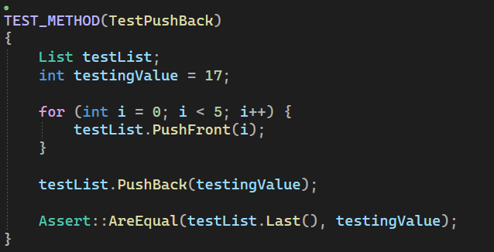

**Expected Result:**

At the end of the for loop the list will be populated with values (final order 5, 4, 3, 2, 1).

Which leaves 1 as the returned value of testList.Last(). To test that PushBack(testingValue) adds 17 to the last position of the list, the test compares the equality of last and the value passed by PushBack().

**Actual Result:**

Test Passed.

**Insert()**

**Test Implemented:**

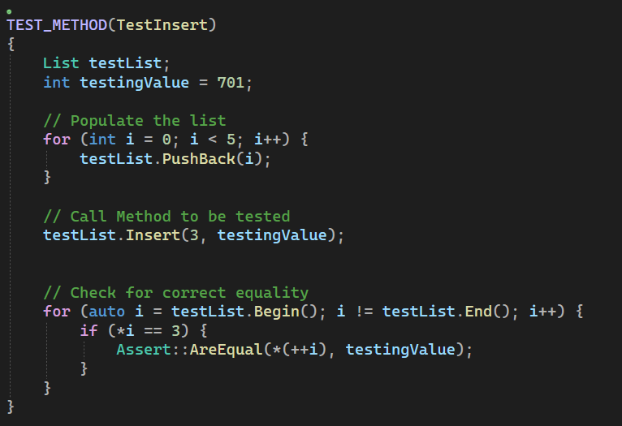

**Expected Result:**

Similarly to the previous test, a small list is populated and the method being tested is called. In this instance the expected result is that the testingValue (701) will be inserted after finding a node with the value 3.

**Actual Result:**

Test Passed

**Remove()**

**Test Implemented:**

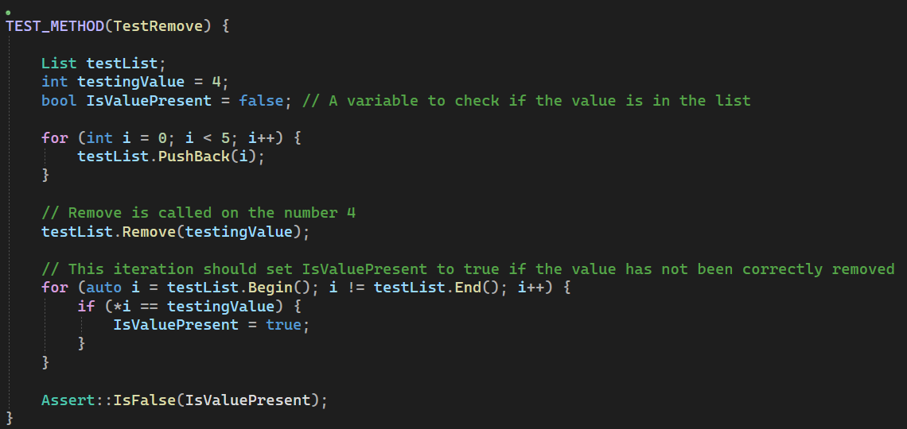

**Expected Result:**

Admittedly not the most robust test as IsValuePresent isn’t set to true when 4 is added into the list in the first place. But should the testing value be present in the list after having called remove the test would fail.

**Actual Result:**

Test Passed